2017 Czech Open
Youth "A" Championships
Prague, Czech Republic, from 9 June to 11 June 2017

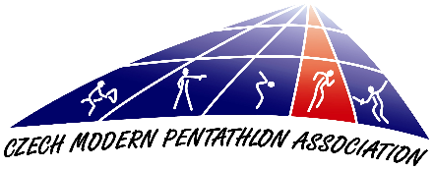
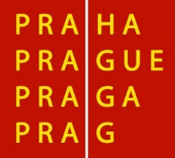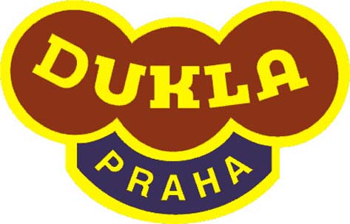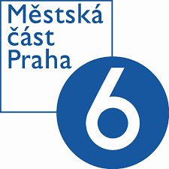

Dear Friends,

The Czech Modern Pentathlon Association in cooperation with ASC Dukla Praha has
the pleasure of inviting a delegation of your country to participate in the 2017 Czech Open Youth "A" (Under19) Championships that will be held in Prague, from 9 June to 11 June 2017, according to provisional schedule below:

9 June Friday
Arrival of participants
20:30 Technical Meeting

10 June Saturday – Individual
08:00 Fencing – girls
10:00 Swimming - boys
12:00 Fencing - boys
12:30 Swimming – girls
14:30 Laser-Run – girls
16:00 Prize giving ceremony - girls
16:30 Laser-Run - boys
18:00 Prize giving ceremony

11 June Sunday – Mix relay
09:00 Fencing
12:30 Swimming
14:20 Laser-Run
15:00 Prize giving ceremony
RULES
The competition will be carried out according to the current UIPM Rules.
Swimming: 25 m indoor swimming pool / 6 lanes (Juliska)
Fencing: 9+1 pistes
Combined Event: 30+3 (or 18+2) precision laser targets (PLT); mostly hard surface, spikes are not recommended (Juliska)

Czech Modern Pentathlon Federation invites at this moment unlimited number
of the athletes and managers/coaches per National Federation. But the organizers reserve the right to reduce overall amount of the athletes per NF - acceptance of entries will be based on the order of Entry Forms A at the Organising Committee.

FINANCIAL CONDITIONS
As it is approved by the UIPM, all delegation members (including athletes, coaches
and officials) have to pay as follows:
Entry form C received prior to 5 th May:
€ 40 for double room per night per person (30 rooms)
€ 50 for single room per night per person (5 rooms)
Entry form C or changes received after to 5 th May:
€ 50 for double room per night per person
€ 60 for single room per night per person
Prices include entry to the competition, local transport, accommodation - 1 night in single or double room with breakfast, lunch packets - only competition days (Saturday, Sunday) and dinner. (Start with dinner, finnish with breakfast).

Delegations are required to send by bank transfer a minimum of 30 percent of the total amount of their accommodation invoice until 5th May, otherwise the reservation will not be guaranteed. After receiving final Form C and the non-refundable 30 percent deposit, we will send you an invoice for the remainder of the total cost for your delegation. This may be paid in cash (Euros only) at the accreditation desk on arrival, or sent by bank transfer in advance.

Bank details
Account name: Cesky svaz moderniho petiboje
Name of bank: GE Money Bank, a. s.
Bank Address: Vitezne Namesti 577/2, Praha 6, 160 00
Account number - EUR: 215541701/0600
IBAN code: CZ5806000000000215541701
SWIFT code: AGBACZPP

All extra cost for bank transfer should be worn by the national federation.

Nations wishing to arrange their own accommodation must pay € 80 per person
per competition accreditation fee which is also required to be paid in cash
at the accreditation desk on arrival. For this, we will provide lunch packets
for the competition days and allow access to official transportation between competition sites.

TRANSPORT
Transportation from the Prague international airport (or Prague railway station) to the official hotel and the return journey is only guaranteed if arrival information is provided in good time and according to the deadline on Entry Form C. Transportation from the official hotel to the venue for athletes will be according to the competition programme.

ENTRY FORMS
We would appreciate early confirmation of your intention to participate
or not and submit this as Entry Form A.

Deadlines for the Entry Forms are as follows:
Form A (informative): before 31st March
Form B (preliminary): before 20th April
Form C (final): before 5th May

INSURANCE and ATHLETES’ LICENSES
Athletes are only allowed to participate in UIPM sanctioned events if they are
in possession of a valid UIPM issued Athletes License. According to UIPM Rules all members of attending delegations should insure themselves in case of accidental injury
or illness. The organizer will not accept any responsibility financial or other, for any loss, injury or illness of any member of the delegation.

EQUIPMENT CONTROL
Fencing equipment control take place on the piste before the start of the first bout. Pistol check will generally take place at competition site and starts 120 minutes before CE starts. It will be possible to check your shooting equipment on Saturday, 10 June,
from 12 a.m. at the pentathlon center (just close to the swimming pool) as well.

VISAS & VACCINATIONS
The LOC cannot accept responsibility for arranging visas but can provide specific letters of invitation if needed. For information if you need a visa or vaccinations please contact your nearest Embassy or Consulate.

OFFICIAL ADDRESSES
Czech Modern Pentathlon Association

Address: Zátopkova 100/2, 169 00 Prague 6

Tel.: +420 725937843 (L. Grolichová)

E-mail: czechopen@pentathlon.cz
CMPA website: www.pentathlon.cz

Swimming and CE:

Competition venue: Army Sport Center Dukla, Juliska Athletic Stadium

Address: Na Julisce 28/2, 160 00 Prague 6 – Dejvice

Fencing:

Competition venue: Multi-purpose Sport Center "Pod Juliskou"

Address: Pod Juliskou 4, 160 00 Prague 6 – Dejvice

Accommodation: Hotel DAP***

Address: Vítězné náměstí 4/684, Praha 6, 160 00, www.daphotel.cz

We hope to see your delegation in Prague.
Best regards,
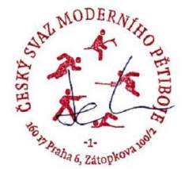
.....................................
Bohumil HRUDKA
Chairman of the LOC
President of the CMPA
2017 Czech Open
Youth "A" Championships
Prague, Czech Republic, from 9 June to 11 June 2017

ENTRY FORM “A”
Return not later than 31st March

Nation: _______________________ Contact Person:________________________

Tel : ______________ Fax :_______________ E-Mail: _______________________

PARTICIPATION : estimated Number of Persons, mix relays

Men Women Mix relay

Athletes

Coaches /Officials

ACCOMODATION: Mark with “X”:

The Delegation will stay in the Official Hotel YES NO

IF YES:
Double rooms n. _______ from_____________ to____________
Single rooms n. _______ from ____________ to____________

Return to Czech Modern Pentathlon Association

Tel.: +420 725937843 (L. Grolichová)
E-mail: czechopen@pentathlon.cz

Name (printed) + signature:

Date:

2017 Czech Open
Youth "A" Championships
Prague, Czech Republic, from 9 June to 11 June 2017

ENTRY FORM “B” (Preliminary)
Return not later than 20th April

Nation: _______________________ Contact Person:________________________

Tel : ______________ Fax :_______________ E-Mail: _______________________

Male Athletes  Surname | First Name | ID Number | Date  of Birth | Passport No. | Group  No.
Female Athletes  Surname | First Name | ID number | Date of Birth | Passport No. | Group  No.

Officials Surname | First Name | Function | Passport No.

Group No. | Arrival Date | Time | Flight nr. | Departure Date. | Time | Flight nr.

ACCOMODATION: Mark with “X”:

The Delegation will stay in the Official Hotel YES NO

IF YES:

Double rooms n. _______ from_____________ to____________
Single rooms n. _______ from ____________ to____________

Return to Czech Modern Pentathlon Association

Tel.: +420 725937843 (L. Grolichová)
E-mail: czechopen@pentathlon.cz

Name (printed) + signature:

Date:

2017 Czech Open
Youth "A" Championships
Prague, Czech Republic, from 9 June to 11 June 2017

ENTRY FORM “C” (Final)
Return not later than 5th May

Nation: _______________________ Contact Person:________________________

Tel : ______________ Fax :_______________ E-Mail: _______________________

Last Name | First Name | Function | Arrival Date | Time  (Flight No.) | Type of  transport | Depart. Date | Time  (Flight No.) | Room Type (S/D)  Room - mate

Return to Czech Modern Pentathlon Association

Tel.: +420 725937843 (L. Grolichová)
E-mail: czechopen@pentathlon.cz

Name (printed) + signature:

Date:

