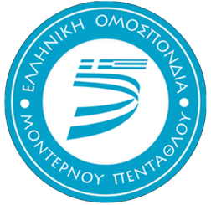
Hellenic Modern Pentathlon Federation

2022 Biathle, Triathle and Laser Run European Championships

Marathon, Greece 6th – 9th October 2022
Goudi Olympic Park, PO Box 14178, 11527 Athens, Greece

Entry Form A
Deadline: 1st August 2022

Nation: _________________________________________

Contact Person: _________________________________

Tel:____________________________________________

Email:__________________________________________

Estimated Number of Participants

Gender | Men | Women
Athletes
Coaches
Other

Signature: ___________________________Name Printed: ____________________________

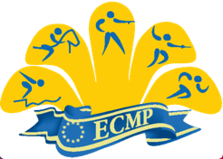
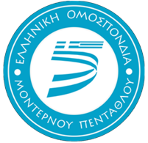
Date: __________________________________________

