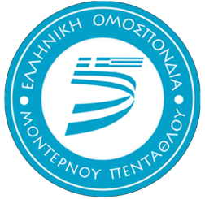

Hellenic Modern Pentathlon Federation

2022 Biathle, Triathle and Laser Run European Championships

Marathon, Greece 6th – 9th October 2022
Goudi Olympic Park, PO Box 14178, 11527 Athens, Greece

Entry Form B
Deadline: 1st September 2022
Nation:

_________________________________________________________________________________

Contact Person: __________________________________________________________________________

Tel: _________________________________ Email: __________________________________________

Athlete Name | D.O.B | Age Category | Gender (M/F) | Laser Run | LR Mixed | Biathle | Biathle Mixed | Triathle | Triathle Mixed | T-Shirt Size

(* If needed please insert more rows)
(** T-Shirt Size’s – XS, S, M, L, XL, XXL)

Signature: __________________Name Printed: __________________Date: __________________

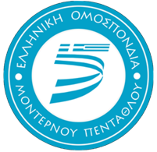

Athlete Name | D.O.B | Age Category | Gender (M/F) | Laser Run | LR Mixed | Biathle | Biathle Mixed | Triathle | Triathle Mixed | T-Shirt Size

Payment Details

Account Name: Hellenic Modern Pentathlon Federation
Account Number: 349-00-2002-002951
Swift Code CRBAGRAAXXX

IBAN: GR66 0140 3490 3490 0200 2002 951

Bank Name: ALPHA BANK

