2020 Czech Open Under 17 & 19 Championships
Prague, Czech Republic, from 28th August to 30th August 2020

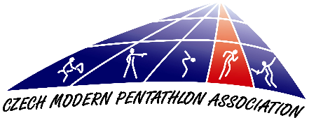
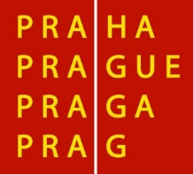

Dear Friends,

The Czech Modern Pentathlon Association in cooperation with ASC Dukla Praha has
the pleasure of inviting a delegation of your country to participate in the 2020 Czech Open Under 17 & 19 Championships that will be held in Prague, from 28th August to 30th August 2020, according to provisional schedule below:

28th August Friday
Arrival of participants
20:30 Technical Meeting U17 (Men) & U19 (Women) (Hotel Krystal)

29th August Saturday
U17 Men´s competition
U19 Women´s competition

20:30 Technical Meeting U17 (Women) & U19 (Men) (Hotel Krystal)

30th August Sunday
U17 Women´s competition
U19 Men´s competition

(Time schedule will be specified according to the number of registered athletes)
The Czech Modern Pentathlon Association invites at this moment unlimited number
of the athletes and officials/coaches per National Federation. The organizers reserve the right to reduce the overall amount of the athletes per NF. The entries acceptance will be based on the arrival order of the Entry Forms A at the Organising Committee.

RULES
The competition will be carried out according to the current UIPM Rules.
Swimming: 25 m indoor swimming pool / 6 lanes (Juliska)
Fencing: 12 pistes (Juliska)
Laser Run: 36+3 precision laser targets (PLT) model 2020; tartan (Juliska)
The competition will count towards pwr – if fulfilling the criteria according to UIPM Competition Rules and Regulations R 1.19.2

FINANCIAL CONDITIONS
As it is approved by the UIPM, all delegation members (including athletes, coaches
and officials) have to pay as follows:

- € 70 for double or triple room per night per person
- € 90 for single room per night per person
Prices include entry to the competition, local transport, accommodation - 1 night in single, double or triple room with breakfast, lunch packet and dinner. (The meal plan begins with dinner on the day of arrival and ends with breakfast on the day of departure).

Delegations are required to send by bank transfer a minimum of 30 percent of the total amount of their accommodation invoice until 15th August, otherwise the reservation will not be guaranteed. After receiving final Form C and the non-refundable 30 percent deposit, we will send you an invoice for the remainder of the total cost for your delegation. This may be paid in cash (Euros only) at the accreditation desk on arrival, or sent by bank transfer in advance.

Bank details
Account name: Cesky svaz modeniho petiboje
Name of bank: MONETA Money Bank, a. s.
Bank Address: Vitezne Namesti 577/2, Praha 6, 160 00
Account number - EUR: 215541701/0600
IBAN code: CZ5806000000000215541701
SWIFT code: AGBACZPP

The payee will be responsible for all bank charges incurred by Cesky svaz moderniho petiboje for bank transfers and must select this option when making the payment.
Nations wishing to arrange their own accommodation must pay € 80 per person
per competition accreditation fee which is also required to be paid in cash
at the accreditation desk on arrival. For this, we will provide lunch packets
for the competition days and allow access to official transportation between competition sites.

TRANSPORT
Transportation from the nearest airport (or railway station) to the official hotel
and the return journey is only guaranteed if arrival information is provided in good time and according to the deadline on Entry Form C. Transportation from the official hotel
to the venue for athletes will be according to the competition programme.

ENTRY FORMS
Deadlines for the Entry Forms are as follows:

Form A (informative): before 25th July
Form B (preliminary): before 5th August
Form C (final): before 15th August

We would appreciate early confirmation of your intention to participate via email to czechopen@pentathlon.cz

If, on arrival for the competition, the team has less athletes and/or team officials/coaches than listed on their Final Entry Form and without informing the Organizing Nation/LOC at least 7 days prior to their arrival, the NF will pay a fine to the Organizing Nation/LOC of 200 Euros for each person not attending.

INSURANCE and ATHLETES’ LICENSES
Athletes are only allowed to participate in UIPM sanctioned events if they are
in possession of a valid UIPM issued Athletes License. According to UIPM Rules all members of attending delegations should insure themselves in case of accidental injury
or illness. The organizer will not accept any responsibility financial or other, for any loss, injury or illness of any member of the delegation.

EQUIPMENT CONTROL
Fencing equipment control takes place on the piste before the start of the first competition round. Pistol check will generally take place at the competition site and starts 120 minutes before Laser Run start. It will be possible to check your shooting equipment on Saturday 29th August from 1 a.m. and Sunday 30th August from 2 a.m at the shooting range as well.

VISAS & VACCINATIONS
The LOC cannot accept responsibility for arranging visas but can provide specific letters of invitation if needed. For information if you need a visa or vaccinations please contact your nearest Embassy or Consulate.

OFFICIAL ADDRESSES
Czech Modern Pentathlon Association

Address: Zátopkova 100/2, 169 00 Prague 6

Tel.: +420 778 889 333 (Bohumil Hrudka)

E-mail: hrudka@pentathlon.cz, czechopen@pentathlon.cz
CMPA website: www.pentathlon.cz

Swimming, Fencing and Laser-run:

Competition venue: Army Sport Center Dukla, Juliska Athletic Stadium

Address: Na Julisce 28/2, 160 00 Prague 6 – Dejvice

Accommodation:

Hotel Krystal*** José Martího 407/2, 162 00 Prague 6 – Veleslavín

We hope to see your delegation in Prague.
Best regards,
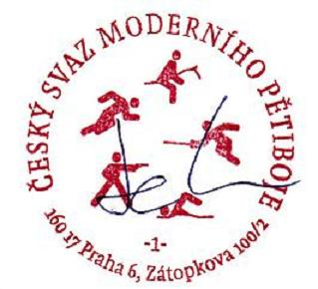

.....................................
Bohumil HRUDKA
Chairman of the LOC
President of the CMPA

