Memorial Milan Kadlec 2020
Prague, Czech Republic, from 19th August to 23rd August 2020

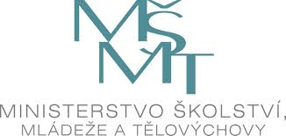
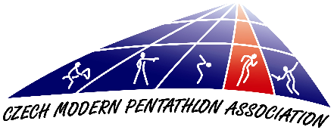
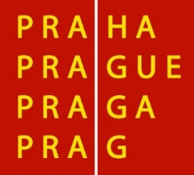

Dear Friends,

The Czech Modern Pentathlon Association in cooperation with ASC Dukla Praha has
the pleasure of inviting a delegation of your country to participate in the Memorial Milan Kadlec 2020 that will be held in Prague, from 19th August to 23rd August 2020, according to schedule below:

19th August Wednesday
Arrival of participants
20:30 Technical Meeting Semifinal Women´s competition

20th August Thursday
Semifinal Women´s competition
20:30 Technical Meeting Semifinal Men´s competition

21st August Friday
Semifinal Men´s competition
9:00 Jumping test
20:30 Technical Meeting Final Women´s and Men´s competition

22nd August Suturday
Women´s competition
9:00 Riding
13:30 Swimming
15:00 Fencing
18:00 Laser Run

23rd August Sunday
Men´s competition
9:00 Riding
13:30 Swimming
15:00 Fencing
18:00 Laser Run

RULES
The competition will be carried out according to the current UIPM Rules.
Swimming: 25 m indoor swimming pool / 6 lanes (Juliska)
Fencing: 10 pistes (Juliska)
Laser Run: 36+3 precision laser targets (PLT) model 2020; tartan (Juliska)
Riding: 2x18 horses (Poděbrady)
The competition will count towards pwr – if fulfilling the criteria according to UIPM Competition Rules and Regulations R 1.19.2

FINANCIAL CONDITIONS
As it is approved by the UIPM, all delegation members (including athletes, coaches
and officials) have to pay as follows:

- € 100 for double room per night per person
- € 120 for single room per night per person
Prices include entry to the competition, local transport, accommodation - 1 night in single or double room with breakfast, lunch packet and dinner. (The meal plan begins with dinner on the day of arrival and ends with breakfast on the day of departure).

Delegations are required to send by bank transfer a minimum of 30 percent of the total amount of their accommodation invoice until 5th August, otherwise the reservation will not be guaranteed. After receiving final Form C and the non-refundable 30 percent deposit, we will send you an invoice for the remainder of the total cost for your delegation. This may be paid in cash (Euros only) at the accreditation desk on arrival, or sent by bank transfer in advance.

Bank details
Account name: Cesky svaz modeniho petiboje
Name of bank: MONETA Money Bank, a. s.
Bank Address: Vitezne Namesti 577/2, Praha 6, 160 00
Account number - EUR: 215541701/0600
IBAN code: CZ5806000000000215541701
SWIFT code: AGBACZPP

The payee will be responsible for all bank charges incurred by Cesky svaz moderniho petiboje for bank transfers and must select this option when making the payment.
Nations wishing to arrange their own accommodation must pay € 180 per person
per competition accreditation fee which is also required to be paid in cash
at the accreditation desk on arrival. For this, we will provide lunch packets
for the competition days and allow access to official transportation between competition sites.

TRANSPORT
Transportation from the nearest airport (or railway station) to the official hotel
and the return journey is only guaranteed if arrival information is provided in good time and according to the deadline on Entry Form C. Transportation from the official hotel
to the venue for athletes will be according to the competition programme.

ENTRY FORMS
All competitors must have a valid UIPM license for modern pentathlon (including riding).
Deadlines for the Entry Forms are as follows:

Form A (informative): before 15th July
Form B (preliminary): before 25th July
Form C (final): before 5th August

We would appreciate early confirmation of your intention to participate via email to kadlecmemorial@pentathlon.cz

If, on arrival for the competition, the team has less athletes and/or team officials/coaches than listed on their Final Entry Form and without informing the Organizing Nation/LOC at least 7 days prior to their arrival, the NF will pay a fine to the Organizing Nation/LOC of 200 Euros for each person not attending.

INSURANCE and ATHLETES’ LICENSES
Athletes are only allowed to participate in UIPM sanctioned events if they are
in possession of a valid UIPM issued Athletes License. According to UIPM Rules all members of attending delegations should insure themselves in case of accidental injury
or illness. The organizer will not accept any responsibility financial or other, for any loss, injury or illness of any member of the delegation.

RIDING ABILITY
Athletes are only allowed to participate in UIPM sanctioned events if they are in
possession of a valid Athletes License. Registration is not possible without a License
Number. If an athlete does not have a license, they will not be allowed to take part in
the competition. You are reminded of Rule 1.12.1 ii): Pentathletes without riding ability
listed in the database and without a letter/ certificate from their NF confirming their
ability to ride may compete in competitions, but not in the riding phase. In addition, the
athlete must show sufficient riding ability already in the warm up, otherwise he will not
be allowed to compete in the riding phase.

EQUIPMENT CONTROL
Fencing equipment control takes place on the piste before the start of the first competition round. Pistol check will generally take place at competition site and starts 120 minutes before Laser Run start. It will be possible to check your shooting equipment on Thursday 20th August and Friday 21st August, from 1:00 pm at the shooting range as well.

VISAS & VACCINATIONS
The LOC cannot accept responsibility for arranging visas but can provide specific letters of invitation if needed. For information if you need a visa or vaccinations please contact your nearest Embassy or Consulate.

OFFICIAL ADDRESSES
Czech Modern Pentathlon Association

Address: Zátopkova 100/2, 169 00 Prague 6

Tel.: +420 778 889 333 (B.Hrudka)

E-mail: hrudka@pentathlon.cz, kadlecmemorial@pentathlon.cz
CMPA website: www.pentathlon.cz

Swimming, Fencing and Laser Run:

Competition venue: Army Sports Center Dukla, Juliska Athletic Stadium

Address: Na Julisce 28/2, 160 00 Prague 6 – Dejvice

Riding:

Competition venue: Sports Center Poděbrady,

Address: U Jízdárny 196, Poděbrady

Accommodation:

Hotel Krystal*** José Martího 2/407, 160 00 Prague 6

We hope to see your delegation in Prague.
Best regards,

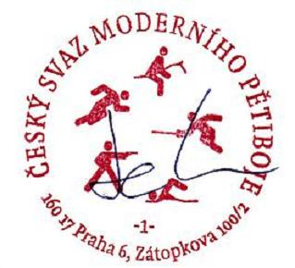

.....................................
Bohumil HRUDKA
Chairman of the LOC
President of the CMPA

