 | European U15 & Junior Championships  13 – 18 August 2024 Sofia Bulgaria | 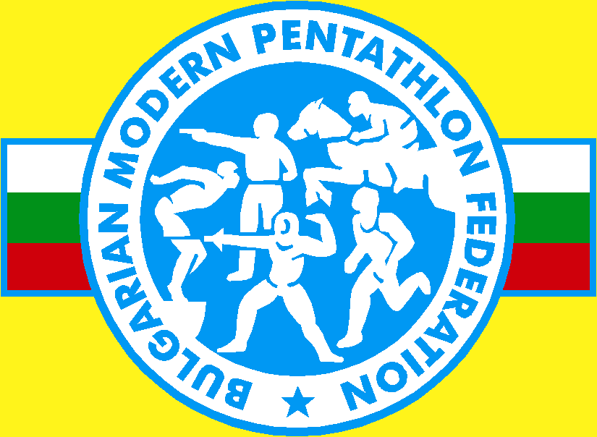
INVITATION LETTER

Dear Friends,
The Bulgarian Modern Pentathlon Federation has the pleasure to invite a delegation of your country to participate in the European U15 & Junior Championships 13 – 18 August 2024, Sofia Bulgaria.
according to the following program:

 | U 15 | Juniors
11-12 August 2024 | Arrival | Arrival
13 August 2024 | Women’s Qualification | Men Relay
14 August 2024 | Men’s Qualification | Women Relay
15 August 2024 | Women’s and Men’s Finals | Women’s Qualification
16 August 2024 | Women Relay | Men’s Qualification
17 August 2024 | Men Relay | Mixed Relay
18 August 2024 | Mixed Relay | Women’s and Men’s Finals
19-20 August 2024 | Departure | Departure

Note: Detailed times schedules are to be confirmed
Competition Rules:
The competition will be carried out according to the UIPM Rules.
Swimming: | 25 m indoor swimming pool/5 lanes
Fencing: | 10 pistes indoor
Obstacles: indoor  Laser Run: | 36+2 reserve shooting ranges with precision laser targets APEOM .  Indoor and outdoor

Competition Venues
Swimming – Sport Complex Academica
Fencing , Obstacles and Laser run will be at Festivalna Hall .

Participation Quota

In the category U15, the participation number of athletes per nation is 8 men and 8 women for the individual competition (but the best 4 athletes per nation can qualify to the final). There is an unlimited number of officials. In case of a withdrawal of any athlete already qualified for the final,

European Championships

13 – 18 August 2024, Sofia Bulgaria

the next athlete in the ranking by points from any nation will replace him/her. Two relays per nation will be accepted, however, only the higher ranked relay team from the same nation can count towards the ranking and can be on the podium.

In the Junior category, the participation number per nation is 4 men and 4 women for the individual competition. One relay will be allowed per nation.

Accommodation
All participants will be accommodated at Hotel Marinela (5 stars) .
The price includes full board accommodation, local transportation from/to the event and shuttle from / to Sofia International Airport/.

Please note that the Technical Meeting, Accreditation Office and LOC Office etc. will be located in the Hotel.

Transport
Transportation from the airport to the official hotel and the return journey is only guaranteed if arrival information is provided in the registration system in good time and before to the deadline. Transportation from the official hotel to the venues for athletes will be according to the training and competition program.
Financial Conditions
For delegations (athletes, coaches, officials, supporters) reserving full board
Registrations fees
Single |  | 175 € per person per night
Double |  | 155 € per person per night
Room Types Available
Single: 80 rooms
Double: 190 rooms

Each price includes full board accommodation Breakfast (open Buffet) Lunch packets, Dinner (open Buffet), shuttle from / to the event and local transportation from / to Sofia International Airport.

European Championships
13 – 18 August 2024, Sofia Bulgaria

ATTENTION! All extra cost for bank transfer should be worn by the national federation. Otherwise, the amount will be invoiced afterwards.
Paying cash upon arrival is only accepted if you have a written approval from the LOC to do so and all financial conditions (costs) will be calculated on the prices mentioned above.

Bank Account Details:
Name of bank: | DSK Bank
Beneficiary Name: |  | Bulgarian Modern Pentathlon Federation
SWIFT code:  IBAN nr(EUR): | STSABGSF  BG 37 STSA 9300 0014 8146 22

As a reminder, if on arrival at the competition, teams arriving with fewer athletes, coaches and/or officials than submitted in the registration system and without informing the Organizing Nation/LOC at least 7 days prior to their arrival, the NF will have to pay a fine to the Organizing Nation/LOC of 200 € for each person not attending.
Deadlines

All information must be submitted, including flight information, pistol serial numbers, accommodation bookings, name of the athlete, License ID number, starting time for swimming etc. by 20 July 2024 to Entry Forms and send to e-mail: office@pentathlon-bg.com
Deadlines are as follows:
Participation Confirmation: 10 July 2024
Hotel Registration: 20 July 2024
Deadline to transfer total amount: 25 July 2024
If we do not receive complete information of your delegation bеfore to closure of the registration system or we do not receive your delegation's payment, confirmation then we will consider your delegation as non-participating.

ATHLETES’ LICENSES

Athletes are only allowed to participate in UIPM sanctioned events, if they are in possession of a valid UIPM issued Athletes License. Entry Forms will not be accepted, if any athlete is missing his/her License Number

European Championships

13 – 18 August 2024, Sofia Bulgaria

Obstacles

- Steps
- Big Wheel
- 1.5 m wall
- Rings
- Balance Beam
- Wheels
- Monkey Bars
- Finish Wall

Insurance

According to UIPM Rules all members of attending delegations should insure themselves in case of accidental injury or illness. We highly recommend insurance covering COVID -19 cases as well.
The organizer will not accept any financial liability or loss, injury or illness occurred to any participant and or member of delegation.
Laser Pistols

Firearms licenses are not a legal requirement when bringing air and CO2 pistols (cylinders for laser pistols) into Bulgaria for competition purposes.

VISAS & Vaccinations

The LOC can provide specific letters of invitation or invitation by name or communicating with your embassies if needed. For information if you need a visa or vaccinations please contact your nearest Embassy or Consulate. For contacting LOC use office@pentathlon-bg.com

General Information

All athletes are kindly requested to wear their official national uniform at the competition. Please also bring a track/ record of your anthem and a national flag (120 x 80 cm).
Expected Weather conditions: from +22 to +32 Celsius in August
Voltage: 220 V

LOC Contact Details

Please contact directly the LOC for local information regarding family and friends wishing to attend the competition or for any local questions you may have.

Address: Bulgaria , Sofia, bul.Vasil Levski 75

Bulgarian Modern Pentathlon Federation:
Email: office@pentathlon-bg.com
Mobile: +359887508033

We look forward to seeing you in Sofia.

Best regards,

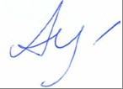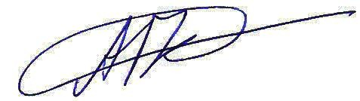

ECMP President BMPF President

Tatiana Ardabieva | Andrey Kuzmanov

