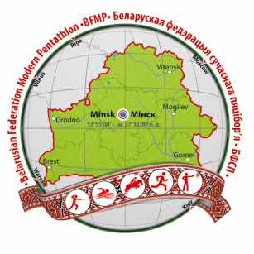 | European Junior Championships,  Minsk, Belarus  17-23 June, 2014

ENTRY FORM “B” (Preliminary)

Return no later than May 17, 2014
Please complete using capital letters

Nation _____________________________ Contact person:_________________________
Tel: Fax : Email: ______________________

Male athletes
Surname | First name | UIPM № | Date of birth | Passport № | Pistol model | Serial №
Female athletes
Surname | First name | UIPM № | Date of birth | Passport № | Pistol model | Serial №
***No athlete will be admitted to the competition without a valid international license***
Coaches/Officials
Surname | First name | Function | Passport № | M/F | Arrival date | Airport

Signature: _________________________Name (printed):___________________________

Date: _____________

Return to: Belarusian Federation of Modern Pentathlon, contact person Elena Iskhacova

E-mail: blrpentathlon@mail.ru

