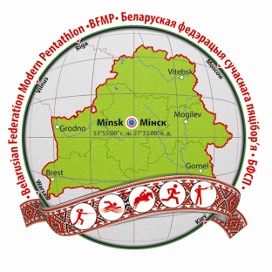 | European Junior Championships,  Minsk, Belarus  17-23 June, 2014

ENTRY FORM “C” (Final)

Return no later than June 3, 2014

Nation: _______________________ Contact Person:________________________
Tel: _________________ Fax: _________________ E Mail: _______________________

No | Last Name | First Name | Function | Arrival Date | Time | Flight | Departure Date | Time | Flight | Room Type (Sgl/Dbl) | Rooming Partner

Signature: _____________________________ Name (printed): _______________________ Date:_______________________

Return to: Belarusian Federation of Modern Pentathlon, contact person Elena Iskhacova
E-mail:blrpentathlon@mail.ru

